New Edinburgh
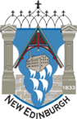
Community Alliance (NECA)
Annual General Meeting
&
Forum for a Park Vision
Wednesday Oct. 25, 7 pm
St. Bart’s Church Hall, 125 MacKay St.
Come join fellow residents to hear about and discuss what’s going on in the ‘burgh!
Refreshments provided.
VISIT newedinburgh.ca to download the AGM information package

